No 1.

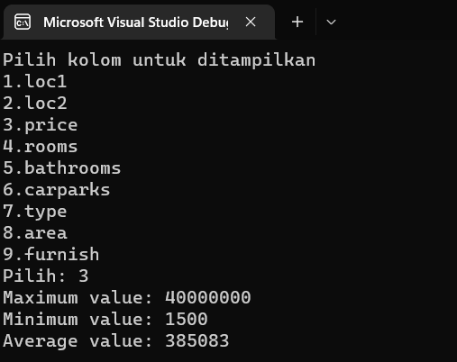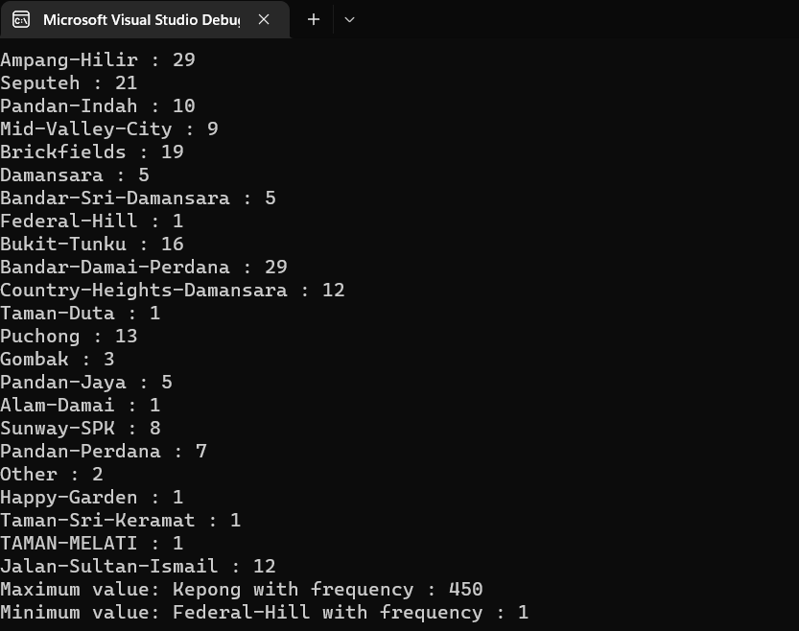

|  |  |
| --- | --- |
| Function MinMaxAverange | Function show_minimaxFrequency |
|  |  |
| Function File |
|  |
| Function add_housing |
|  |

Flowchart main()

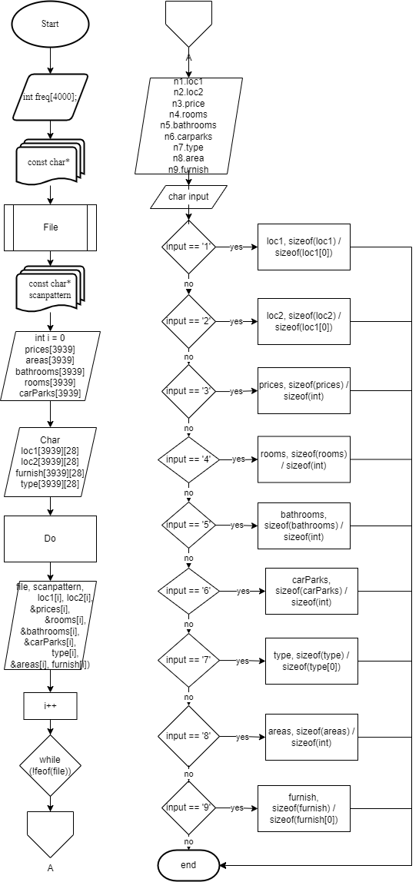

No 2.

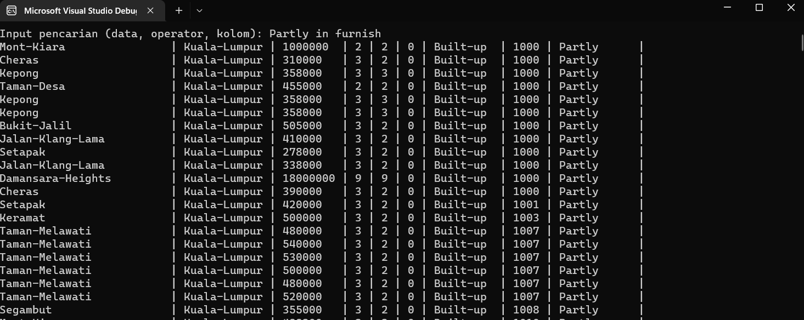

|  |  |
| --- | --- |
| Function Display Housing | Function File |
|  |  |
| Housing | List Housing |
|  |  |
| New_listhousing | New_housing |
|  |  |
| Function pust_ListHousing |
|  |

|  |
| --- |
| Function Display Housing |
|  |

|  |
| --- |
| Function search housing |
|  |

Flowchart Main()

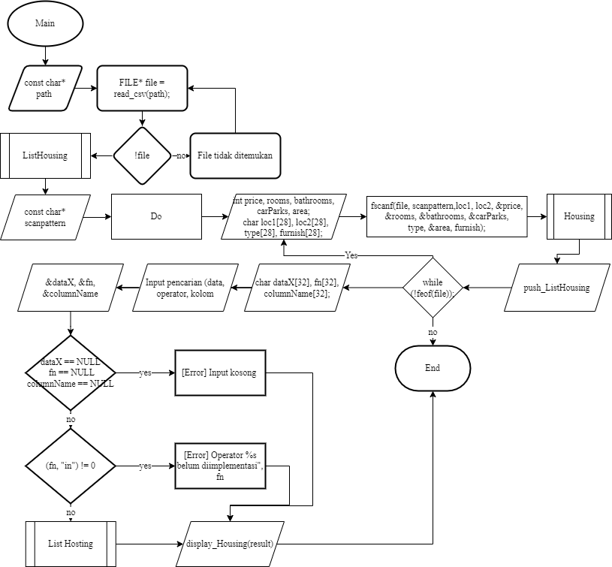

No 3.

Screenshot

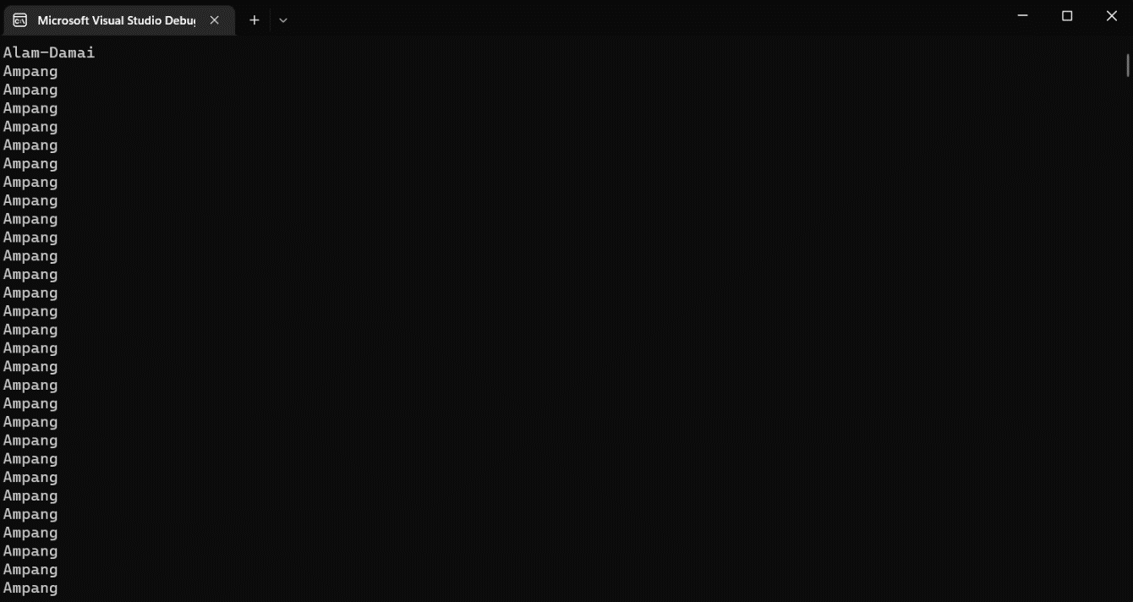

Flowchart

|  |  |  |
| --- | --- | --- |
| Function new_string | Function File | Function List_String |
|  |  |  |
| String | Sort_list | New_listring |
|  |  |  |
| Function Display List | Function Push_string |
|  |  |

Flowchart Main()

